Guide to putting the application on Amazon Elastic Beanstalk*

(Subject to Change)

# Files and Requirement (Pre-AWS)

## Application.py

To ensure the correct version of the application is up (“Production Mode”, instead of “Debug Mode”). Go to ‘application.py’ and have the correct line uncommented.



## Files in Zip

We want to make sure the correct files are being put into AWS. AWS likes to have a compressed version of a folder to be uploaded, so this helps with that process. I liked to recreate and copy these files into a folder to later compress/zip. The required files placed in the root:

## 

## Docker (optional)

We don’t need to use Docker on our local machine since we’ll be uploading to AWS. Beanstalk will figure it all out once it sees our ‘Dockerfile.’

# AWS Elastic Beanstalk

## Getting Started

* + 1. Head to AWS/Elastic Beanstalk and hit ‘Create Application’

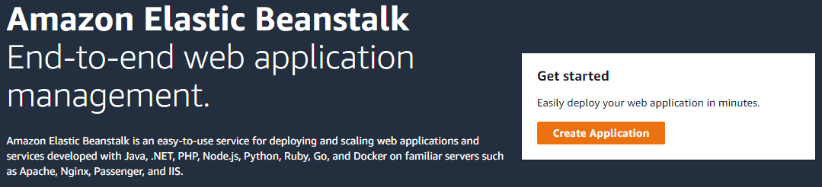

* + 1. Fill Application Name, with desired name.
    2. In Platform, **Choose Docker**

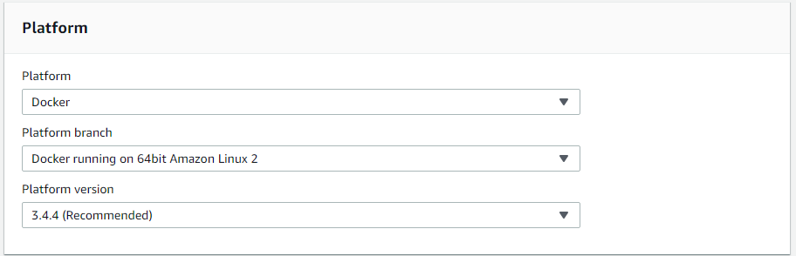

* + 1. In Application Code, Choose **Upload your Code** and Upload the Zipped folder from Part 1.

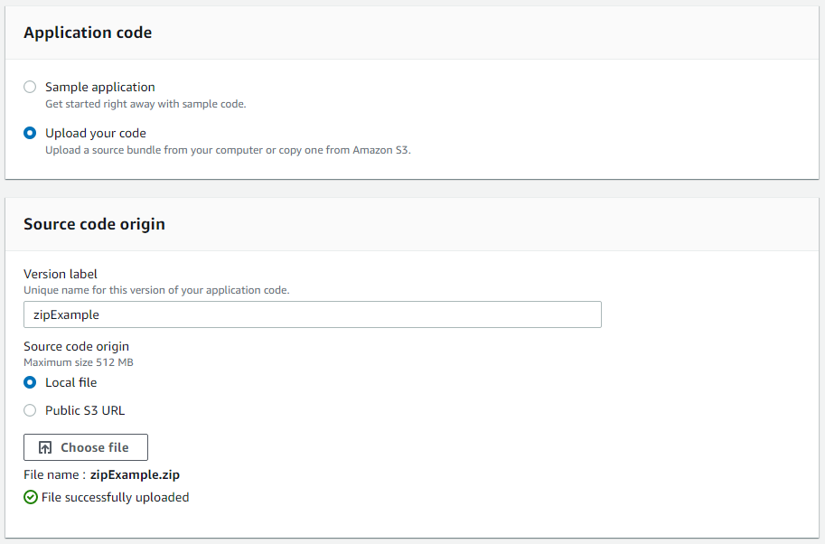

* + 1. Finally choose ‘**Configure more options**’

## Configuration

* + 1. Capacity – In Capacity - > Auto scaling group - > Instance type
       1. We choose a **C5.Large** as the instance type since we need a minimum of 2 vCPU and 4GiB of Memory.
    2. Instances – In Instances -> Root volume (boot device) -> Root volume type
       1. We choose a **General Purpose (SSD)** with a size of **16 GB** because we want to make sure AWS has enough space to install our files as well as the required libraries.

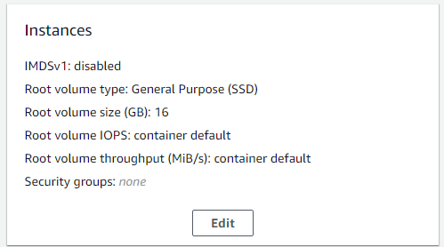 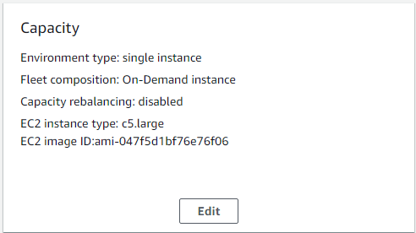

* + 1. Create Application